UPES August Update from Mr. Briggs-Hale
Time to Get Your “Learn” On!

Back To School Night, Friday, August 28: 5 – 7:00 PM
- Welcome and Introductions: 5:00 PM
- PreK – K Orientation & 2 -6 informal
Classroom visits 5:30 PM
- Ice Cream Social 6:00 PM

First Day of School, Monday, August 31, First Bell: 7:55 AM
School Accountability, Tuesday, September 1: 5:00 PM
First PTO, Tuesday, September 16 PM: 6:00 PM

We Can’t Wait for School!
We are excited to share with you some enhancements to our program of learning for this coming school year. We thought you’d enjoy on a jump on ways we’ve fine-tuned our program to better serve your child.

Needless to say, the staff at Ute Pass Elementary School is very excited to start teaching and learning with you child!

Spring Survey:

We were very pleased with the almost 90% return rate of our 2015 Spring Survey. If you haven’t heard already, Beth Apotheker won the $200 City Market Gift Card from our random drawing of responses sent to Survey Monkey!

We will analyze the results of this survey together with you this coming fall at our School Accountability meetings (always the hour before PTO).

I was especially pleased with the constructiveness and quality of the written responses. These have already helped immensely in my thinking about ways to improve our school and how to better serve your family.

You can find our survey results on our website. Here’s the link:
We will also have copies in our office. Or, just give us a call and we can email the PDF to you.

New Staff:

Jamie Montoya-De Smidt has joined the staff at Ute Pass Elementary School as our new GATE teacher and Counselor. Mr. Montoya-De Smidt is a veteran teachers and counselor who most recently spent the past ten years as the counselor at Broadmoore Elementary School. We are very excited to welcome him to our community.

With a passion for classical literature, Shakespeare, and the type of learning our students experienced with Destination Imagination, Mr. Montoya-De Smidt brings a wealth of experience, a uniquely engaging style with kids, and a huge tool belt of ways to deepen thinking for all children. Your kids are going to love Mr. “M.D.”

New Curriculum Spurs Fascination! (Not to be confused with the Federal Common Core Standards!)

I am also very pleased to announce that UPES will adopt the vaunted Core
Knowledge Curriculum next year, including the Core Knowledge Language Arts (CKLA) literacy program and the Core Knowledge Sequence for Social Studies and Science. During our work across the 2014-15 school year, the UPES staff has been examining the fundamentals of learning that will keep public education relevant to your child well beyond the year 2020. With the selection of this curriculum we are providing your children the most powerful foundation for future learning possible.

A common value across our community has been to ensure we have engaging thematic curriculum that is presented in fascinating, authentic, empowering units. Core Knowledge Curriculum, developed from concepts in the book Cultural Literacy by University of Virginia Professor E.D. Hirsch, Jr., offers a K-5 framework our Ute Pass Elementary in the Year 2020 (and beyond) planning. Units via a detailed language arts program integrated with Science and Social Studies units called “domains” throughout.

Among the main tenets of the program are that a more developed knowledge base among children enables better reading comprehension and vocabulary—and builds a hunger for more knowledge. It evens the playing field for disadvantaged children exposed to less background knowledge than their peers—and yet offers unlimited enrichment and exploration to even our most gifted students! More simply, in Core Knowledge, elementary students get to actually learn real historical or scientific content, instead of just isolated skill drills alone. The following table lists the major domain units at each grade level:
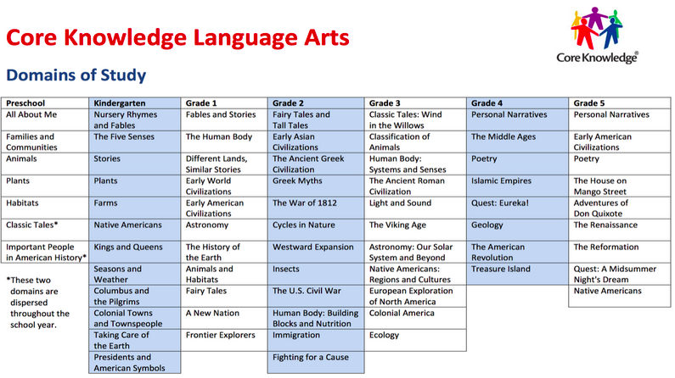

An End to The Testing Days in August! It’s your child, not your child’s “data” that we want to get to know first!).

During the era of high stakes testing, our staff felt inclined to gather as much academic data about each child as possible before school started. However, recent changes in how we assess children at UPES have allowed much of this testing to be accomplished during regular instructional time. Thus, we have decided to de-emphasize the idea that “the test” comes before the learning and will simply start full-days of school on August 31. We are very excited about this change and believe the data that we most need is the data we often collect every day in the classroom.

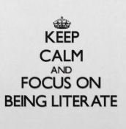
Assessment That Meet the Teacher’s Needs:

With a more coherent, sequenced curriculum, the need for constant dipstick standardized testing has been reduced. Thus, we will only be using our STAR Reading and Math Assessments to provide your child and you with useful information around our marking periods. Last year we used this assessment five times. This coming year we will use it only three times.

New After School Choirs

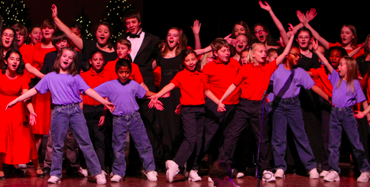
Ute Pass Elementary School and Manitou Springs School District are the homes to two new regional youth choirs through the Colorado Springs Children’s Chorale:
The High Altitude Youth Choir (HAYC) for grades 3 – 6
The Overture Choir for grades K-2

These choirs are being INTEGRATED with the Instrumental programs at both UPES
and MSES to be offered Wednesday afternoons (at UPES and MSES without bussing).

The combined focus will be for a Wednesday/Thursday after school Music Intensive.
Wednesday will be focused on developing Instrumental skills and Thursday
through the HAYC and Overture) on performance and choral skills. Both are
necessary to be a highly educated musical person.

The two choirs will be offered through Arts14 and will following their fee structure.

A huge thank you to Wendy Fay for making this program so possible for both
elementary schools!

Chickens? Probably not, after all…

Well, it was a nice idea. The issue of attracting other wildlife onto school grounds was one we could not get around. Never-the-less, a heartfelt thanks to everyone who encouraged us to keep learning hands-on and real for our kiddos!

Cold Frame Gardens:

Catherine Wilson has been working with our Buildings and Grounds department
and the Boy’s Scouts Eagle Scout program to build a Kitchen Garden for our school.
The plans are drawn up and we should begin construction this year.

20-Mile March:

In 1911 and 1912, Robert Scott and Roald Amundsen raced to be the first to reach the South Pole. An analysis of why Amundsen was successful and Scott was not reveals many fascinating things about how humans learn and plan for the unknown. One key lesson from Amundsen was to define exactly how far one would travel in a day, no matter what the conditions. Unlike Scott, whose team surged and stopped, often because of over-exhausting themselves, Amundsen instilled a clear set of principles and daily goals with his team. One of these was this: Rain or shine we make 20 miles per day.

In our effort to integrate the feedback we’ve received from community and parents, the staff at UPES has created a unique document that precisely defines what our daily work with your child will be. It’s our version of Amundsen’s 20 Mile Daily March. Essentially, it’s a way for us to focus our mission statement into specific behaviors and outcomes each and every day.

We are very proud of this document and plan to continue developing it and integrating it into all aspects of our work with your family.

Our UPES Daily Commitments.

The Ute Pass Elementary School Daily 20-Mile March

Relationships:

With passionate intensity and while being present for each other, and with joyfulness and fun, we build, honor, real and imperfect, powerful human relationships. We act on things that encourage wellness, environmental awareness and sustainability while working always to deepen the strength of the mind and body connection.

We ensure we have connected community of students, staff and parents who listen, value all opinions, and ensuring we respond with transparency and confidentiality.

Each day,

Students go home excited and feeling connected and challenged; are confident their teacher knows and understands them; can identify what steps to take to reach higher levels of performance, actively seek different perspectives, and use high-level interpersonal skills that are kind, of high character, and compassionate.

Rigor:

With passionate intensity and while being present for each other, we think, reflect, share, and plan for the highest levels of rigorous, sequenced, cross-curricular, and interdependent school environment building essential human knowledge,

Each day,

Students become knowledgeable and highly skilled, interpersonally and academically. They advocate for themselves and others, seek or build partnerships, demand quality feedback, take ownership of their learning and responsibility for their actions, demonstrate knowledge and competence, use many strategies for deep reflection and thought and are tenacious workers who expect to achieve and contribute at the highest levels

Opportunity:

With passionate intensity and while being present for each other, we act to strengthen and expand a family of individuals committed to creating learning opportunities, both structured and personalized while fostering curiosity, citizenship, self advocacy, enthusiasm, and a seeker mindset in every student. We actively build partnerships that add value both inside and outside the school building.

Each day,

We deliver students who connect with their community partners, engage in acts that serve others, advocate for needs not able to be met during the school day, and reach out to those in need.

